1. **Introduction**
   1. **Research Background**
      1. Aviation Industry Overview

There are estimated that over 100,000 commercial aircrafts fly in the world each day. In 2018 (HKCAD,2023), there were in total 427766 take-off or landing recorded in the Hong Kong International Airport. Before the cockpit crew starts the aircraft, flight planning would be conducted to establish the details such as route, flight path, schedule time, and fuel. The cockpit crew would also make pre-flight briefing and checks to ensure all the members know the estimate conditions, restrictions, and relevant information (e.g. Notice to Airman NOTAM) of the flight and make sure the aircraft is airworthy. Throughout the flight, the cockpit crews and the air traffic controllers in different sections continue to communicate to ensure safe and efficient operation.

* + 1. Corperation Between Cockpit Crew and Air Traffic Controller (ATC)

To perform safe and efficient operations of aircraft, in controlled airspace, ATC use designated radio frequency to communicate with cockpit crew. The cockpit crew coordinates the flight plan and reports position, altitude, and intention to ATC, who in turn provides clearance, information, and instructions to maintain appropriate distances for safe aircraft operation. If an emergency occurs, air traffic controllers provide guidance and assistance to the cockpit crew while coordinating with other related parties to resolve the issue safely.

* + 1. Possible Failure Model

Throughout the flight, there are a variety of situations that can cause a loss of control, so an immediate safe landing is the top priority. These situations include single or dual engine failure, abnormal on flight control surfaces, and fuel starvation. When there is soul on board requires medical assistant, or any event that does not affect aircraft performance but is potentially hazardous, the cockpit crew might need assistance to divert into the best airport as soon as possible. Cockpit crews are not expected to calculate the precise performance of the aircraft in these emergency situations.

* 1. **Problem Description**
     1. Human Reaction Time Under Emergency or Abnormal Situations

The Human Reaction Time varies differently depending on the specific situation and the individual proficiency of the cockpit crew. A team of well-trained and experienced of cockpit crew should have high sense of situational awareness and have high familiarity with the procedures, to adopt the real time situation and make correct decisions quickly. However, there are still a gap of time which might be crucial to safety of aircraft. In the case of Hudson Miracle, pilots in simulator could successfully land in all nearby runway when they eliminate all the human reaction time in the simulations.

* + 1. Standard Procedures Under Emergency or Abnormal Situations

When there the aircraft is abnormal, the cockpit crew first need to determine the situation, then settle a consensus before deciding which the final decision would be endorsed by the captain. Then the cockpit crew would make distress or urgency call as required the ATC to gain support from them. The ATC will then enquire information and situation in the radio while discuss the solution, such as available alternate airport/runway with the cockpit crew. The pilot then attempts referencing the procedures of the Quick Reference Handbook and Flight Manual to eliminate existing problem. If there is lack of time, the pilots would attempt to look for a nearby safer ground to make an emergency landing.

* + 1. Limitation On Real Time Communication in Emergency or Abnormal Situations

ATC and cockpit crew uses Very High Frequency (VHF) as their communication radio. However, radio signals might still be distorted or weaken due to distance, terrain, or weather situation, etc. Clear and reliable communication between cockpit and the ground might be difficult to establish in emergency situations. At the same time, radio congestion might be occurred when there is high volume of radio transmissions in the same channel. This could delay the request and support between the cockpit and the ground. Although there may be emergency frequencies in some areas for use in emergencies, these channels still cannot guarantee smooth communication between pilots and the ground. Simplicity in conversation might be crucial when quality of radio communication is limited.

* + 1. Support To Cockpit Crew Under Emergency or Abnormal Situations

In emergency or abnormal situation, the cockpit crew are busy to gain control of the aircraft or executing emergency procedures as mentioned above, which the communication between ATC and cockpit crew should be simple and direct to reduce workload and distractions. Furthermore, commercial flight could be flying in non-controlled airspace (Class G Airspace), where ATC are not available to assist and give recommendations to the aircraft in emergency situations. Moreover, aircraft in emergency situations also need to coordinate with other nearby aircraft in Class G Airspace, which greatly increases the workload of the cockpit.

* 1. **Scope**

This paper studies on real time diversion airport advice system regarding to emergency landing. The current plan of A320 pilots to handle abnormal situation is to reference the Emergency and Abnormal procedures (EAC) in the Quick Reference Handbook (QRH). The system based on the initial aircraft conditions, convert them into parameters, and determine the possible flying route while create possible trajectories to the runways nearby. It could lower the workload of the cockpit crew as pilots could save the time to found nearby airport and available runway. Cockpit crew could use suggest the ideal runway to ATC and gain support from the ground while focusing on the emergency or abnormal procedures to eliminate the unsafe issue.

This paper reviews the concept of the Air Traffic Management and human factors when cockpit crew handling abnormal and emergencies. The development of the algorithm and parameters references from Base of Aircraft Data (BADA) developed by Eurocontrol and Open Model for Aircraft Performance and Emissions developed by Dr. Junzi Sun. WRAP

* 1. **Objectives**

This project mainly focuses on the following objectives:

* To collect and analyse real-time aircraft status data.
* To examine the farthest effective flight distance using the real time data of the aircraft to determine
* To develop algorithm calculating the best landing airport option and its flight path through real-time flight data
* To determine whether the system could reduce human reaction time when facing emergency.
  1. **Expected Deliverables**

A real time diversion airport advice system will be proposed in this research. The system is based on the condition of the aircraft to suggest the possibility of landing in nearby runways.

The framework includes the following:

* Conduct literature review in human reactions during emergencies
* Develop program to obtain and analyse real-time aircraft mechanical and dynamical data
* design algorithm method to compute the most appropriate and effective flight path for the available airport design and develop a panel for display
* Test the program and invite personnels to conduct flight with the panel in the simulator
* Analyse the result by comparing the performance between simulations

Standard Instrument Departures (SIDs)

Standard Instrument Departures (SIDs) are used to provide standard route of departure from the terminal control areas to area control area. In Hong Kong International Airport (IATA: HKG, ICAO: VHHH), the terminal control areas implement RNP 1 SIDs, where aircraft using SIDs in Hong Kong should have RNP 1 capability. For runway 07L/R, here is the SIDs (HKCAD, 2023).

There are also 18 noise mitigating SIDs for runway 07R/L, which are normally for use between 1500-2300 UTC. In this project, we simulate a flight from Hong Kong (VHHH) to Sydney (YSSY), referencing a Cathay Pacific flight number CX111’s trajectory, it uses OCEAN2A SID from runway 07R. The requirement of OCEAN2A SID includes:

1. Initial climb to 5,000 ft. Expect further climb when instructed by ATC, but cross PORPA at 5,000ft or below.
2. Minimum climb gradient of 4.9% until leaving 1,400ft is required.
3. Speed restrictions of 205 KIAS or greater at PORPA and 220 KIAS until TD DVOR.

Standard Terminal Arrival Routes (STARS)

Standard Terminal Arrival Routes (STARS) are used to provide standard flight procedures of arrival from the area control areas to terminal control area just before reacing a destination airport. In Sydney (Kingsford Smith) Airport (IATA: SYD; ICAO: YSSY), there are 6 STARs procedure include BOREE3A, BOREE3P, MARLN5, ODALE7 and RIVET3 using RNAV approach (Airservices Australia, 2022). The usual STAR procedure for a commercial aircraft from Hong Kong is BOREE3P if using the runway 16R, a Cathay Pacific flight number CX111’s trajectory.

Standard Procedure For Emergency (Airbus, 2008)

In the Flight Crew Training Manual, abnormal situations are suggested, and procedures are recommended. In case there are smoke in cabin, the main steps include anticipate and initiate diversion and smoke origin identification and fighting. “LAND ASAP” as the one of the most significant point in the Quick Reference Handbook (QRH) in this situation. The procedure is shown below.

In the event of an engine failure, autoland may still be used without one engine operating and AP utilization should be maximized to minimize crew workload. If necessary, it is traditional to conduct a manual approach and landing with one engine inoperative.

As soon as the engine failure is recognized, the PF will simultaneously:

• Set MCT on the remaining engine (largest power on remaining engine)

• Disconnect auto throttle

• Select the speed according to the strategy

• If appropriate, select a heading to keep clear of the airway, preferably heading towards an alternate. Consideration should be given to aircraft position relative to any relevant critical point.

With all engines shut down, cockpit indications will change dramatically as the generators are disconnected. The RAT was deployed to power the emergency generator and pressurize the blue hydraulic circuit. The left-seat pilot must immediately take control of the aircraft and establish a safe flight path.

For fuel leak, the crew should be doing fuel checks when sequencing a waypoint and at least every 30 minutes. When an engine failure occurs, the fuel leak are more difficult to detected and required high situational awareness of pilots to identify the problem. If fuel leak is suspected, the flight crew should follow the flowing procedure.

• If the leak is positively identified as coming from the engine, the affected engine is

shut down to isolate the fuel leak and fuel cross-feed valve may be used as required.

• If the leak is not from the engine or cannot be located, it is imperative that the cross feed valve is not opened.

Under all the above abnormal circumstances, not only the pilots should focus on execute the tasks in the ECAMs or in the flight manual, at the moment the pilot should also identify the best airport for landing as soon as possible. When convenient, emergencies will be reported to ATC using VHF1. Depending on the situation, ATC may provide assistance with other aircraft locations, safe directions, etc. However, if the pilots are busying handling the incoming situation, the communication between the pilots and ATCs might be less prioritized, shorter and clearer communication should be established. This project might advice pilots for a clearer and direct conversation to ATCs under emergency or abnormal situations.

Task Management

Aviate, navigate, and communicate are the three important elements of flight implementation in search of the flying instinct (Katerinakis, T., 2014). Aviate refers to the pilots use the skills to maintain the control of the aircraft; Navigate refers to the pilots know where the aircraft is and find out where it intends to go as destination; Communicate refers to pilots communicate with third parties such as Air Traffic Controllers, Companies, Ground Services. The most important and prioritize part is Aviate, which pilots must control the aircraft in emergency or abnormal situations before complying other action, then would be navigate, knowing where the aircraft land should, and finally to communicate with the ATC. The diversion advisory system could assist pilots in Navigation stage, reducing the time required to explain the situation to ATC and looking for possible runway one by one.

Human Error

Human error is one of the contributing factors in around 70% to 80% of aviation accidents (Sarter, N. B., & Alexander, H. M. ,2000). There are a few types of human errors, including skill-based errors, knowledge-based errors, and rule-based errors.

Skill-based error in aviation refers to pilots making mistakes related to the procedure skills or physical abilities without conscious thinking. It happened when the pilots doing their well-practiced tasks, such as practiced-emergency situations and it is more likely to happened when pilots are fatigue, distracted or under stressful circumstances.

Knowledge-based errors in aviation refers to pilots has no knowledge available to handle an unusual situation. They could only resort to first principles and experience to solve problem with limited understanding and awareness of the situation. These errors are more likely to happened among the less experience pilots when they are facing abnormal or emergency situations airborne.

Rule-based errors in aviation refers to the pilots apply diversly from rule that had been established. These errors are more likely to happened when the rules or procedures are ambiguity, and pilots in time pressure, or without sufficient training in the specific procedure.

These 3 types of errors are not mutually exclusive, when the working environment is not ideal, such as in abnormal or emergency situations, the pilots would be in pressure and loads of procedures would have to followed. No matter experienced or less experienced pilots, they would have a chance to make one or few above errors and mistakes, such as lapse and slips.

According to the study of pilots facing emergency by Bezerra, F. G., & Ribeiro, S. L. (2012), less difficult tasks require higher physical demand while more difficult tasks require more mental demand.

In aviation, physical ability could be significantly increased by training and experience gained, while mental ability relies more on natural abilities. Although there were selection progress such as aptitude tests for future pilots to determine whether they had enough mental ability to due with high intense situations before hiring them, there still differences between pilot and pilot that could not be fixed by training. Therefore, to reduce stress for pilots when they are facing emergency or abnormal situation, systems should be made to reduce tasks for them to worry. This project could reduce workload of pilots in emergency or abnormal situation and hence reduce the possible errors made by the pilots.

Class G Airspace

Class G airspace is the uncontrolled airspace that present the absence for air traffic controllers to provide air traffic management services, only traffic information about other IFR and known VFR fights as far as practicable. According to Federal Aviation Administration (2023), exists wherever that portion of airspace has not been designated as Class A, Class B, Class C, Class D, or Class E airspace. In Hong Kong Flight Information Region, class G airspace exist in the airspace indicated below.

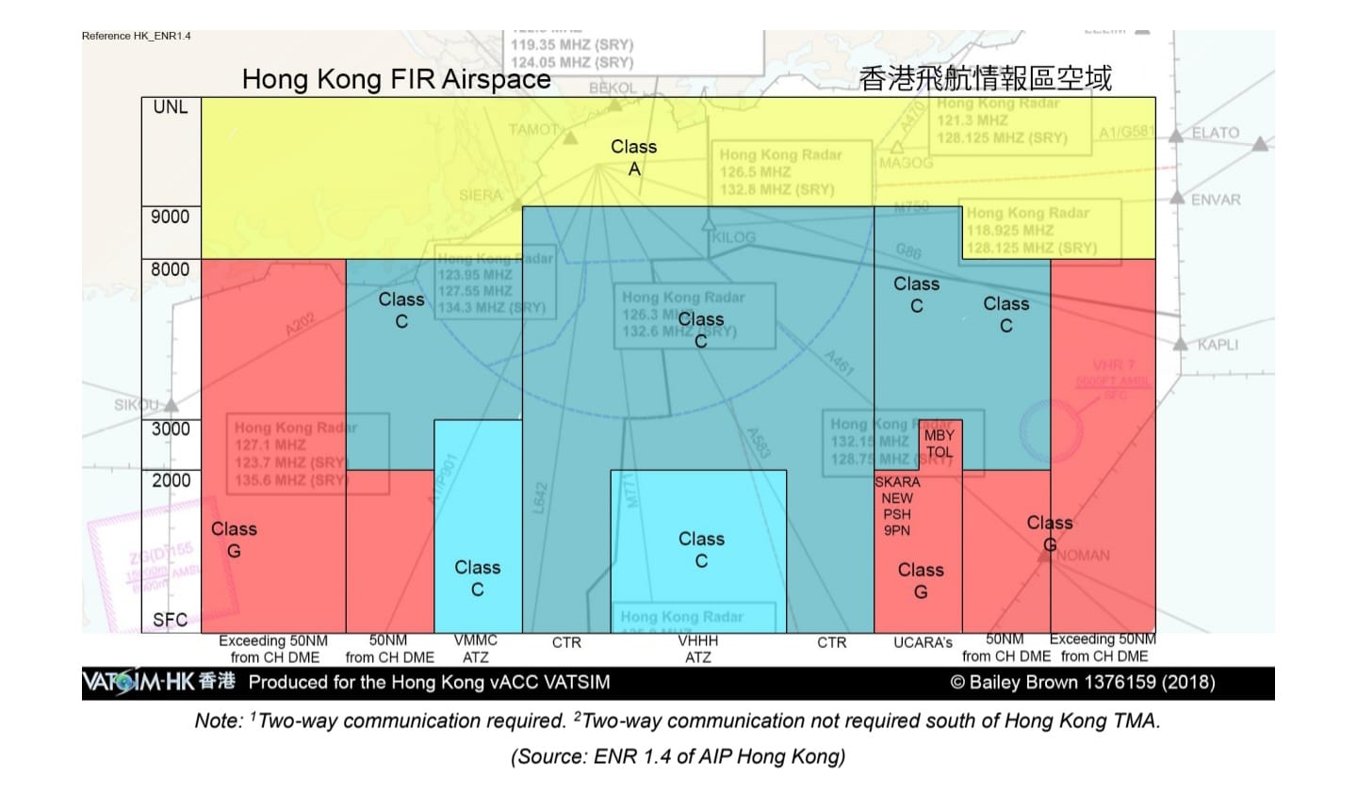

In Class G airspace, since there is lack of ATCs to assist the emergency aircraft for avoiding separations, the pilots on board are required to indicate the situation, position and intension to all nearby aircraft via radio. This highly increases the workload of pilots.

<https://kagoshima.daiichi-koudai.ac.jp/wp-content/uploads/2022/07/R4_report1_2.pdf>

<https://www.a320examiner.com/_files/ugd/969315_d8aef0acd8c14a409279fa89112705af.pdf>

<https://www.737ng.co.uk/A320%20321%20FCTM%20Flight%20Crew%20Training%20Manual.pdf>

<https://www.crc.id.au/xplane/charts/ERSA-2023-SEP-07/00_EMERG%20-%20EMERGENCY%20PROCEDURES.pdf>

Katerinakis, T. (2014). *Aviate, navigate, communicate: Silence, voice and situation awareness in aviation safety*. Drexel University.

Sarter, N. B., & Alexander, H. M. (2000). Error Types and Related Error Detection Mechanisms in the Aviation Domain: An Analysis of Aviation Safety Reporting System Incident Reports. The International Journal of Aviation Psychology., 10(2), 189–206. <https://doi.org/10.1207/S15327108IJAP1002_5>

Bezerra, F. G., & Ribeiro, S. L. (2012). Preliminary study of the pilot’s workload during emergency procedures in helicopters air operations. *Work*, *41*(Supplement 1), 225–231. https://doi.org/10.3233/WOR-2012-0161-225

Endsley, M. R. (1999). Situation awareness in aviation systems. *Handbook of aviation human factors*, *11*, 257-276.

Federal Aviation Administration (2023). Aeronautical Information Manual. Ch.3 Section 3 https://www.faa.gov/air_traffic/publications/atpubs/aim_html/chap3_section_3.html

https://vathk.com/pdf/HKVACC-SOP051-R3.pdf